

Cutting Out

Tue, 20th & Wed 21st May 2025 | 7.30pm

The team at Viv Gordon Company look forward to welcoming you to Cutting Out. Below is the event information with details of location and access information. If you have any queries, please contact: our team via hello@vivgordon.com.

Time, Dates & Location

Dates:

The performances are happening on:

- Tue, 20 & Wed 21 May 2025 | 7.30pm

Timings of all performance dates:

The performance duration is approximately 50 minutes, with no interval.
Theatre space Opens to take your seats and settle*: 7:15pm
Performance Starts: 7.30pm
Performance Ends: 8.20pm (approx)
Post-show Q&A with Viv Gordon: 8.30-9pm (approx)

*If you need to take your seat earlier, this is absolutely possible, just drop us a message. The earliest we can have an audience in the theatre space is 7pm.

Location:
Gloucester Guildhall, 23 Eastgate Street, Gloucester, GL1 1NS
Google Maps link: Gloucester Guildhall

What3Words
Front doors - organs.slurs.back

Website: https://www.gloucesterguildhall.co.uk/

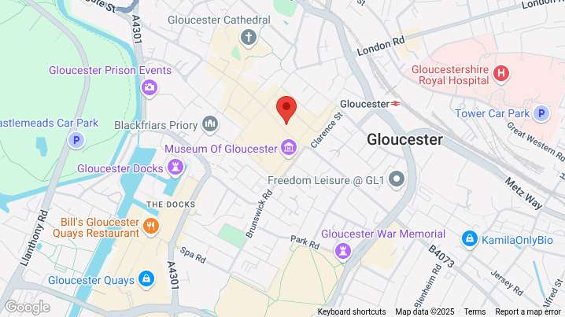

Travel

Parking:

The building is accessible from the Kings Walk car park, there is accessible parking available and an access ramp from the car park to the entrance of the building from the car park. Please note that there is no free parking at the venue and you must pay upon departure from the machines in the car park.
Kings Walk car park address: Kings Walk. Gloucester, GL1 1EA

What3Words: Front doors - organs.slurs.back
Entrance to Kings Walk car park - warns.things.porch
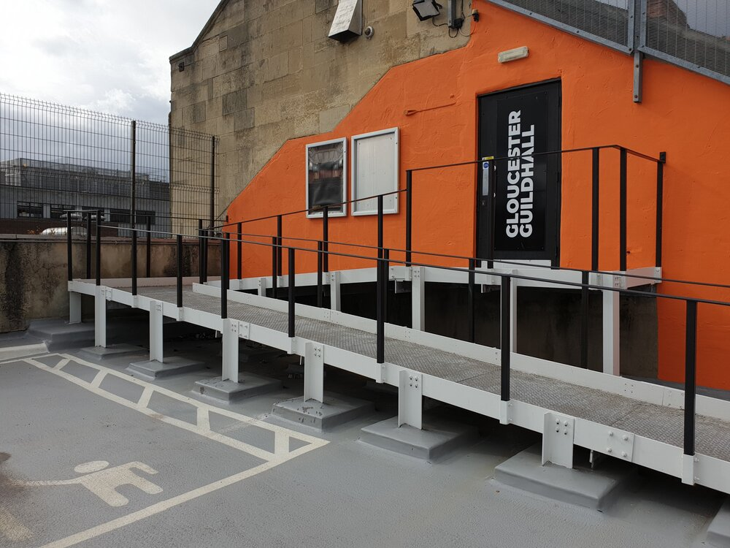
Access from Kings Walk NCP to the Guildhall, from the top floor of the car park.

Drop Off Point:
It is possible to drive to the Eastgate entrance for evening drop off or use the Kings Walk car park.

Public Transport:
The nearest bus stop to the venue is outside Boots, however, Gloucester Transport Hub is only a 5 minute walk from the venue.
You can also access the building from Eastgate Street, and use the lift or stairs to theatre space.
There is on-street bicycle parking outside Boots on Eastgate Street, unfortunately the Guildhall does not have anywhere to store your bike on-site.

Accessing the Venue

Wheelchair access is available to the Guildhall Box Office, Theatre, Bar, and Toilets from the lift at their Eastgate Street entrance and via the entrance from Kings Walk car park. There are also Accessible parking spaces and ramp access via the Kings Walk Car Park entrance on the fourth level.

As access to the main hall requires a set of steps; there is a stair lift available, which is operated by a member of Guildhall staff.

The Guildhall also has an accessible bar area in the Bar. Their bar staff will assist with delivery and ordering of drinks if requested to do so.

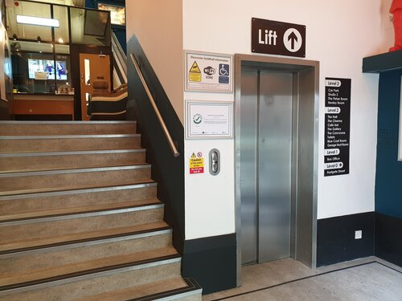

Registered Assistance Dogs are welcome.

Orientation to the Guildhall

For new visitors, the Guildhall offer access maps with pictures and information for people who are new to the venue or who would like to see around in advance, please see links below.

Front Door Accessibility Map (PDF)
Top Door Accessibility Map (PDF)

Floor Plan

You are also welcome to come into the Guildhall and look around before attending an event. No need to prebook, just come when the box office is open and someone can show you around.
Weds - Sat
10:00 - 12:30 OPEN
12:30 - 13:00 CLOSED for 30 mins
13:00 - 16:00 OPEN
Accessible Toilets

At the Guildhall, they have gender neutral toilets, gender specific toilets and three accessible toilets on site.

The accessible toilets are for everyone and are gender neutral. You can find these in the Gallery space on Level 2, outside the George Hunt Room, on Level 3, there is also a radar key accessible toilet along the main corridor just outside the Bar.

The accessible toilet in the Gallery is also where you can find baby changing facilities.

Show Content

All of Viv Gordon Company's work speaks about experiences of child sexual abuse, as our work is a creative campaign to increase voice by, with and for our community.

The show specifically speaks about Viv’s autobiographical story from sexual abuse in childhood, to finding community and activism in adulthood. She also talks about dissociative amnesia and remembering, connected to her experience of abuse; reframing it as part of her survival story.
There will be a wellbeing support person and signposting information available for anyone who needs it.

It is a relaxed environment so it is ok to move, cry, make noise or to leave - We have fidget toys and tissues available in the space for audience use.
A lot of survivors have seen the show and recommend it. They were glad to be in a space where CSA is acknowledged and talked about. They found it empowering and connecting.
If you would like more detailed information about show content ahead of attending or booking tickets, please contact us and we’ll be happy to help.

Additional Access Information

All of our events are relaxed; you can come and leave as you wish to, move around; whatever feels right for you.

There will be stage lights. Flickering lights are used once in the show, for approximately 30 seconds. Within the 30 seconds of flickering, the light level intensifies.

The seating is separate chairs, placed around the stage area, on all sides. Seats are not allocated in advance, so you can select where you would like to sit when you arrive.

As the audience arrive, Viv will be there to welcome everyone into the space.

Signposting

If you are affected by the work, there is support available.

England & Wales Rape Crisis Support Line (available 24/7): 0808 500 2222

The Survivors Trust (National) : www.thesurvivorstrust.org

Survivors UK (men's services): www.survivorsuk.org

We also have wellbeing support on-site if you’d like to talk to them.

