
SMOOSH! Paraorchestra
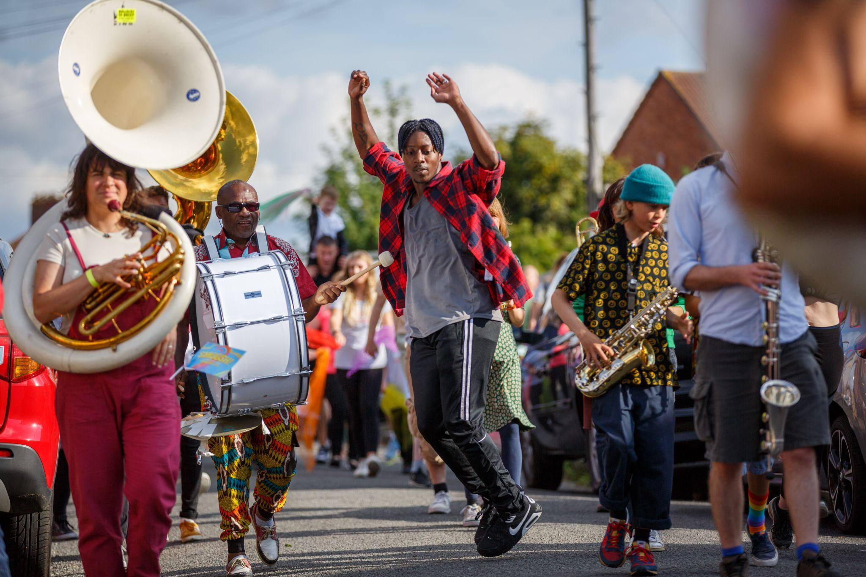

About SMOOSH!

- A parade of music and dance down Tredworth High Street.
- Professional disabled and non-disabled musicians playing many different instruments.
- Local community choir members and school students dancing.
- People holding banners, waving flags and singing along.

What to Expect

 | Who is it for?  - This event is for everyone  - Suitable for all ages  - The event is free  - You do not need to book a ticket
 | Dates and Times:  - Friday 10 July 2026  - 2pm and 6:30pm
 | Length of show:  - Around 45 minutes
 | Access:  - Wheelchair accessible route  - Dedicated access staff  - Ear plugs available  - Assistance dogs welcome
 | Music and Sound:  - The music is played live  - The sound will be loud  - The audience can sing along
 | You are welcome:  - Make noise and move about  - Join and leave at any time
 | Staff:  - Friendly staff  - Happy to help  - Wearing bright orange t-shirts

What happens in the show

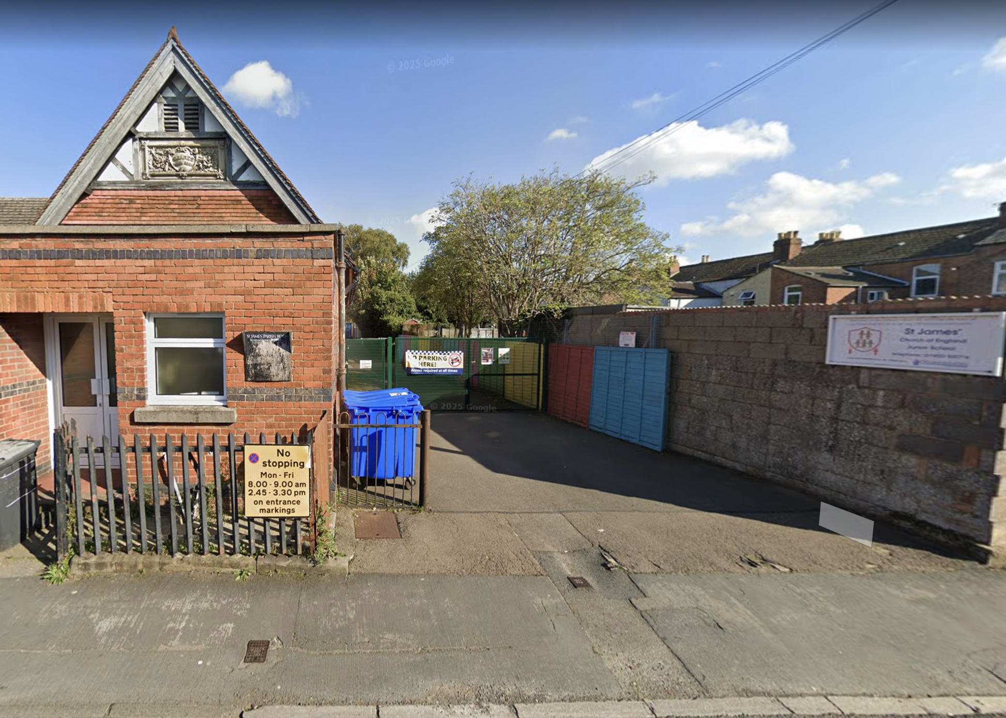 | - The performance starts in the playground at St James Junior School on Upton Street.  - There will be staff to welcome you when you arrive.
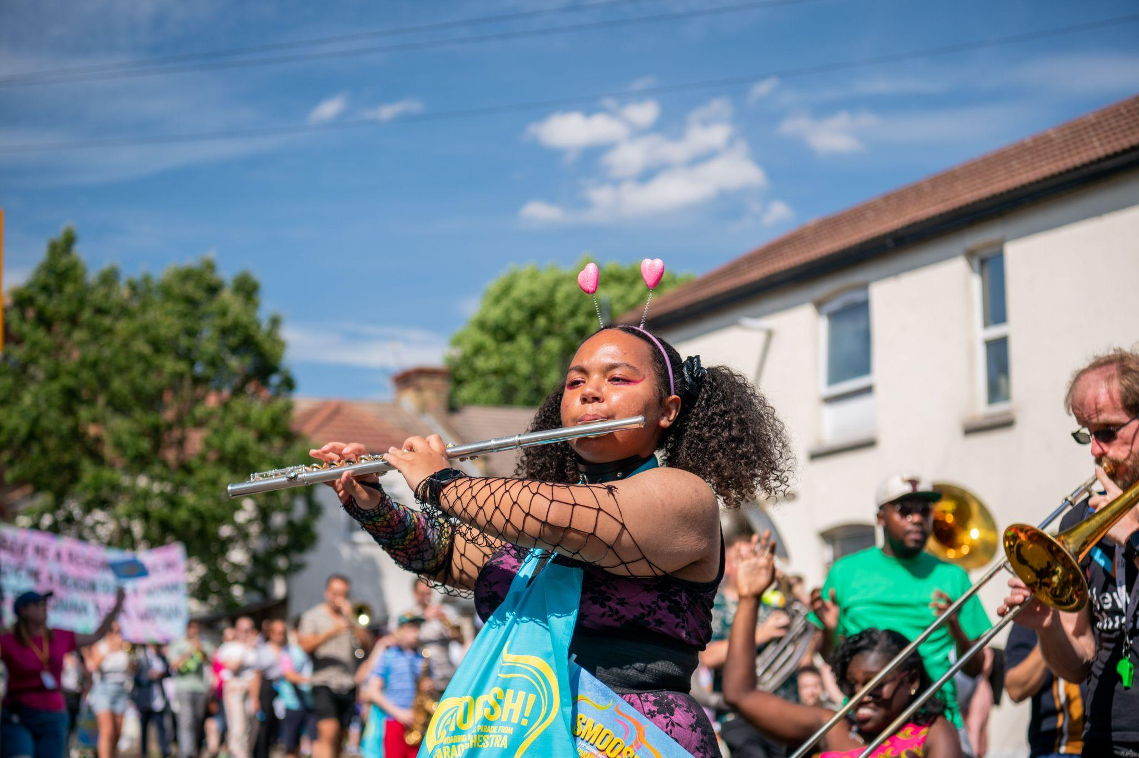 | - The musicians will begin to play.
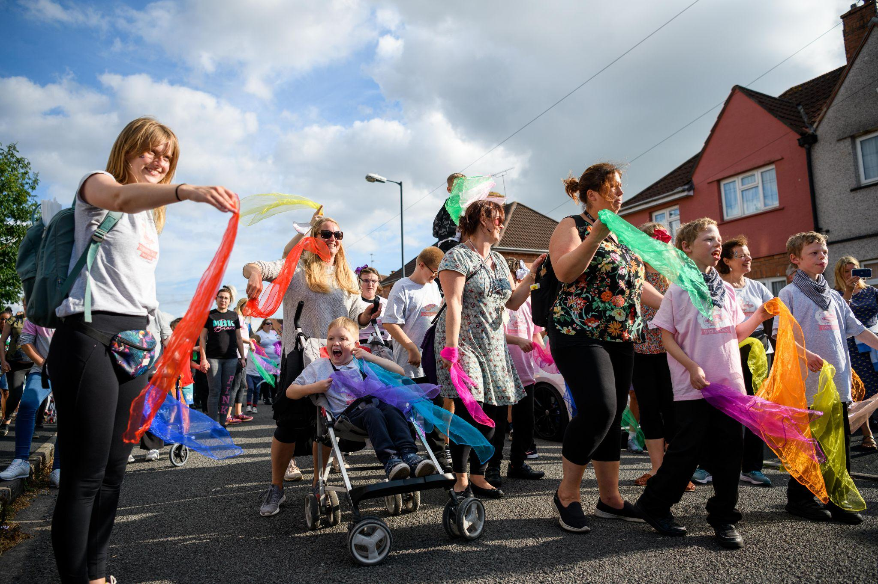 | - The performers will leave the playground.  - The audience will be invited to follow the performers.
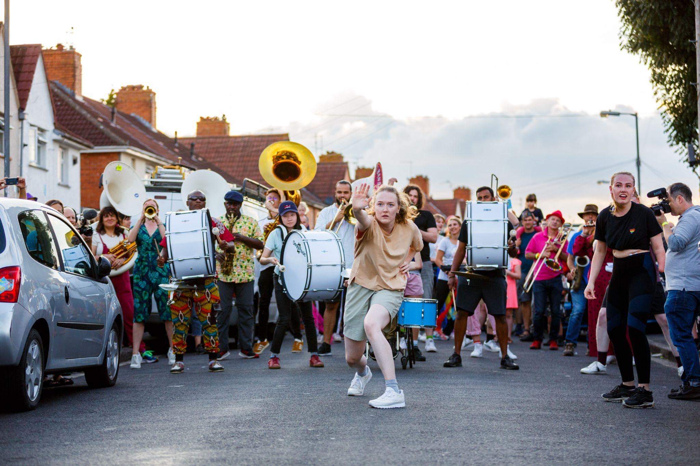 | - The parade will move down Tredworth High Street.  - The road will be closed to traffic.  - Staff will be there to help anyone who needs assistance.
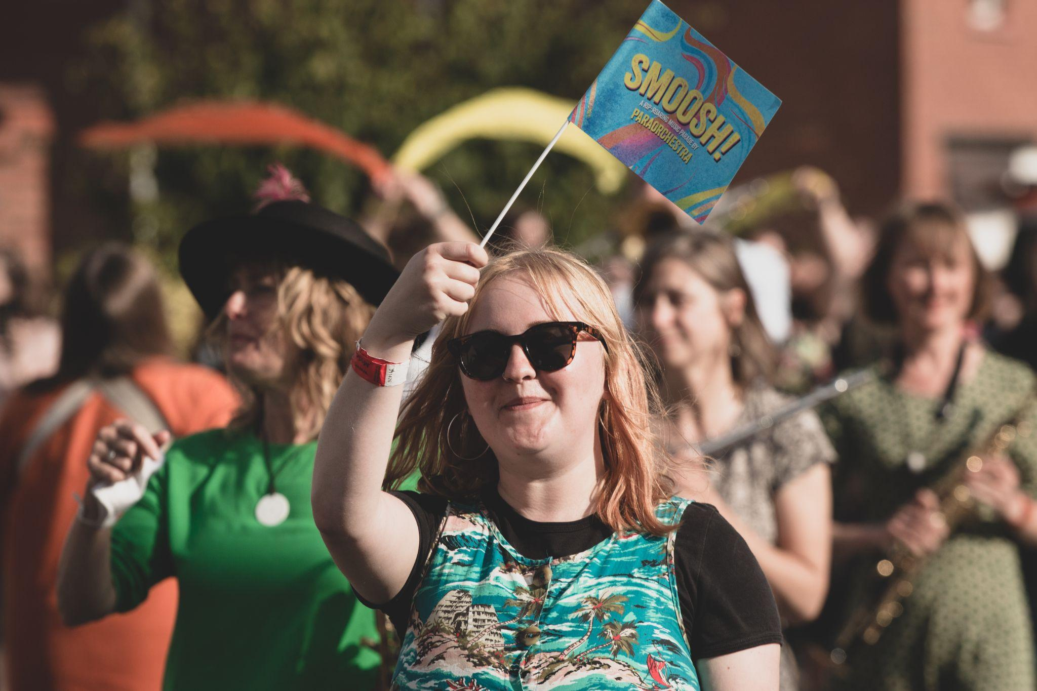 | - People watching will be offered small flags to wave.  - Large banners with short song lyrics will move with the parade.  - Audience members can sing and dance if they would like to.
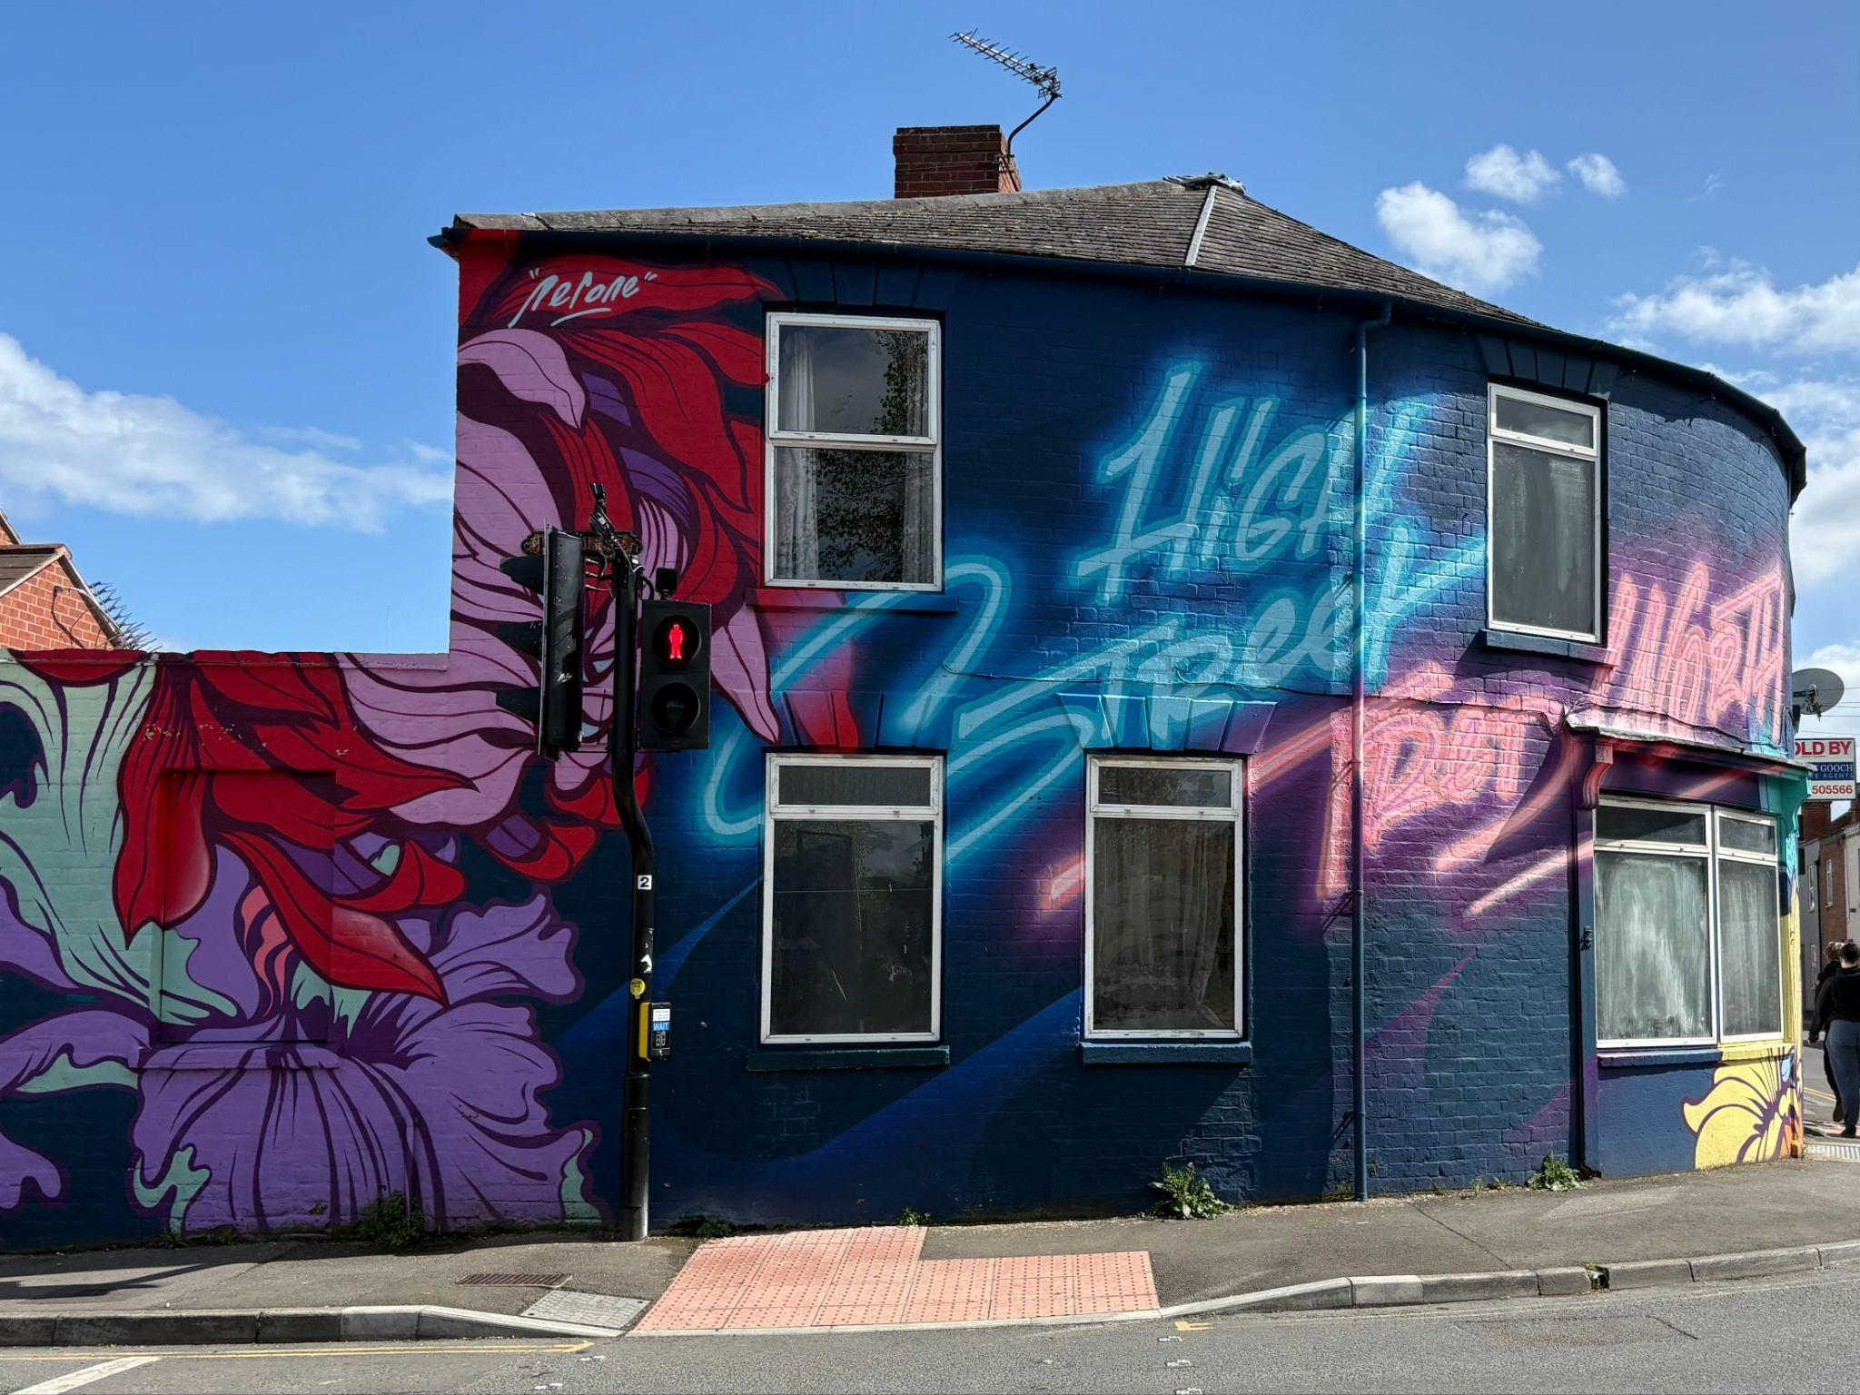 | - At the end of Tredworth High Street, everyone will cross the road together.  - There will be a final song.  - The performance will then end.

Find out more

 | Info about Paraorchestra:  Paraorchestra is an orchestra of musicians playing many different musical instruments. Some of them are disabled and some of them are not disabled. They are led by Charles Hazlewood, a conductor who started Paraorchestra. His title is Artistic Director - this means that as well as conducting the musicians he thinks of ideas for performances and decides what music to play. Paraorchestra concerts are not like normal concerts. They perform many different types of music in unusual places and sometimes include dancers.
 | Info about Strike A Light:  Strike A Light creates one-of-a-kind live experiences in Gloucester.  Gloucester is a diverse city and we make sure that the people we work with, the shows we programme and the companies we support reflect this.  We believe that the arts can change lives and that everyone, regardless of background and circumstance, should be given opportunities to watch, make and participate.
 | Contact us:  Email Jess: info@strikealight.org.uk

