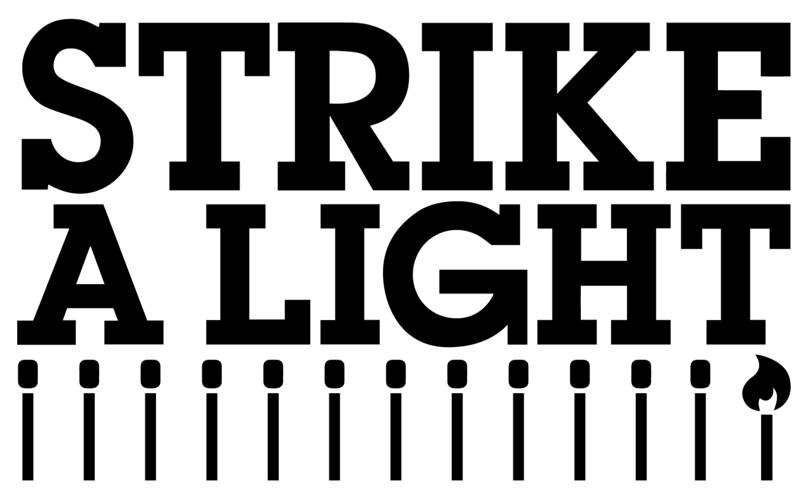
JOB DESCRIPTION
Senior Producer
£34,000 (pro rata) 0.8 FTE

Primary purpose
To lead on the production of all Strike A Light (SAL) events and large scale outdoor work. To manage the budgets for the productions and ensure SAL events reach their aims and objectives, working closely with the Artistic Director and within the vision and aims of SAL. To work closely with the Community Producers to develop and deliver their ideas and projects within the communities of Gloucester, including seeking creative opportunities, setting budgets, and delivering the work.

Specific Duties and Responsibilities

Programmed events
- Work closely with the Artistic Director to plan and produce the programme of events
- To lead on large-scale outdoor projects including creating and managing the budgets, brokering partnership agreements and coordinating the teams involved
- To manage budgets for all events and ensure budgets are maintained, with support from the General Manager and Executive Director
- To coordinate work directly with the Technical Manager, including scheduling and attending regular production meetings
- To scope event space within the city which is original and different, working closely with stakeholders and city partners
- To conduct site visits, with the Technical Manager where appropriate
- To lead on the access provision for productions and innovate new ideas
- To liaise with the General Manager about travel and accommodation requirements for companies
- To liaise with the General Manager on contracts for visiting companies and creative teams
- To ensure evaluation is completed at events and submitted in the appropriate platforms/paperwork for funders
- Work closely with the Head of Participation to produce large-scale Participation events
- To coordinate Front of House, Catering and evaluation for the events
- To collaborate with the Technical Manager on briefings to event staff and technicians and ensure fire safety procedures are in place
- To ensure Health & Safety procedures are in place at events including completing risk assessments in collaboration with the Technical Manager
- To run development programmes for local producers and artists where required
- To work closely with Marking and Communications lead to coordinate appropriate marketing material and on-site brand and presence
- To work closely with the Let Artists be Artists to assist in producing events or expanding reach within Gloucester

Community Producers

- Liaise with the Community Producers and Head of Participation to create new events and engagement activity for their community to sit alongside programmed work
- To work alongside the Artistic Director, and visiting artists and companies, to develop engagement activity around the programme
- Create, manage and maintain the event budgets, reporting regularly to the Artistic Director
- Meet with the Community Producers regularly to support the direction of their work
- Maintain relationships with existing key community and local partners with regular visits to the community settings
- Maintain relationships with funders and ensure events are delivered within set parameters
- Ensure the projects achieve the aims laid out in the funding bids
- Seek development opportunities, including partnerships and networking, for the Community Producers

General
- Work within Strike A Light’s policies, including Health & Safety, Child Protection and Equalities
- Participate in organisation meetings and events as required
- Attend relevant training as and when required
- Positively represent Strike A Light at events
- Any other duties appropriate to the post and organisation
- Identify and develop relationships and undertake advocacy and networking nationally, regionally and locally, to secure funding, partnership and artistic opportunities
- Weekend work will be occasionally required and can be claimed back as TOIL

Line Management Responsibilities
- To manage our Assistant Producer placement, ensuring that they are supported and have a clear work load

Person specification
Skills and Experience
Essential:
- Experience in producing a range of live theatre, dance, music and events
- Experience of creating, managing and working within event budgets
- Experience working closely with communities on projects
- Be approachable and empathetic with the ability to talk to a wide-range of people, including external partners, funders and stakeholders
- Be a self-starter who is happy to manage their own workload independently and stick to tight deadlines
- Be able to work within a small team and be ready to get “stuck in” when needed
- Passionate about the work Strike A Light do
- Have a sound knowledge of equality, diversity, inclusive approaches and of the Social Model of Disability
- Ability to think differently and push against the “norm”
- Ability to work in pressurised environments and remain calm and solution-focused
Desirable:
- Management experience
- Experience of producing in non-theatre locations, including large-scale outdoor events
- A working knowledge of theatre production including working closely with Technical Management
- A knowledge of the current industry and the challenges involved in creating live arts events
- Experience of managing large-funding grants and their requirements, including Arts Council England, Esmée Fairbairn, Paul Hamlyn and The National Lottery
- Have an understanding of General Data Protection Regulation, 2016 (GDPR) and the Privacy and Electronic Communications Regulations, 2003 (PECR)
- Experience of creative producing and able to co-lead creative visions for projects
- Experience of delivering events in a sustainable way
- First Aid trained
- Event Safety Qualification (training can be provided)

