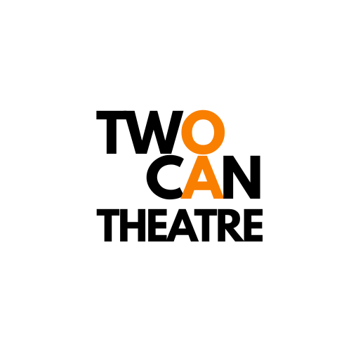
TWOCAN Artist In Residence
APPLICATION FORM

TwoCan Theatre Company is thrilled to launch our very first Artist In Residence Programme

We are looking for two disabled* artists who:
- Are passionate about making live performances and have an idea or project they’d love to explore. (e.g.performance maker, theatre maker, director, writer, puppeteer, dancer, circus performer)
- are based in Gloucestershire (this area is classed as Gloucester, Cheltenham, Tewkesbury, Forest of Dean, Stroud and Cotswold District) and make work in England.
- want space to think, to create.
- to participate in tailored workshops.
- to be mentored by a leading professional.

What we offer:
- An individually tailored programme that runs from January - May 2026
- £3750 for 25 days to think, create, participate, including three mentoring sessions with a leading industry professional, four facilitated workshops tailored by and for you with TwoCan and Strike A Light, as well as being supported by TwoCan’s Artistic Director Nickie Miles-Wildin. This is money for you to spend on ONLY you!
- An additional £1500 for a separate period of research and development in May to explore a creative idea. The artform has to be performance led.
Space will be provided by Gloucester Guildhall and at TwoCan’s venue in Eastington. This fee includes your own fees and anyone else you would like to collaborate with.
- An optional sharing of your work at Gloucester Guildhall or TwoCan Theatre’s venue
- A mentoring session with Emma-Jane Benning (Artistic Director, Strike A Light) and Red Isaac (Lead Producer, Gloucester Guildhall)

*By disabled artist we include anyone who identifies as learning disabled, disabled, Deaf, neurodivergent, are chronically ill, living with a long-term health condition, experience mental health conditions or has access requirements. We fully understand that people use different terminology. You use what’s comfortable for you.

PLEASE NOTE DEADLINE FOR THIS APPLICATION IS: Monday 24th November at midday

Eligibility questions:
- I confirm that I am disabled artist based and living in Gloucestershire
- I understand that the Artist In Residence programmes has to be completed by 31st May 2026.
- I am not in full time education
- I have not received previous funding for the project I am proposing

1. Personal Information:

Name:

Pronouns:

Email:

Contact telephone:

Preferred method of communication:
𜲐Phone 𜲐Email 𜲐Zoom 𜲐Text 𜲐Other 𜲐No preference
Please specify
Application Questions
1. Tell us about you as an artist and what you hope to gain from this residency.
You can tell us about your chosen artform or work you have already created.

You can answer in written format below. (No more than 500 words)
OR
If you would like to answer in video or audio please upload your video or audio recording to a sharing platform (like YouTube, Vimeo, Soundcloud, Dropbox or similar) and then paste the appropriate link in here so we can watch or listen to it.
Don't forget to make sure we can access your link - please include any passwords.

2. What creative idea or project would you like to explore during the bursary?
It doesn’t have to be a fully rounded idea. Give us a list of themes or make a vision board and explain what you have included etc.

You can respond in written format below. No more than 350 words.
OR
If you would like to answer in video or audio please upload your video or audio recording to a sharing platform (like YouTube, Vimeo, Soundcloud, Dropbox or similar) and then paste the appropriate link in here so we can watch or listen to it.
Don't forget to make sure we can access your link - please include any passwords.

Confirm and Submit:
- I have read the application guidelines and I confirm that I am eligible to apply and that the information in this application is true and accurate to the best of my knowledge.

Please email your completed application to: twocan@twocantheatre.org.uk

Application Confirmation
After submitting your application, you should receive a confirmation email. If you don’t see this in your inbox, please contact us as soon as possible, and no later than 24 hours after the deadline, so we can assist you.

Equal Opportunities Monitoring Form
Please download the Equal Opportunities Monitoring Form from the Resident Artist callout and email to: twocan@twocantheatre.org.uk
Please note that this information will not be used as part of the selection process.

Data Protection
To process your application, we will need to collect some personal information. This will be shared with Strike A Light only. TwoCan is committed to best practice in handling personal and sensitive data and fully complies with GDPR regulations.

