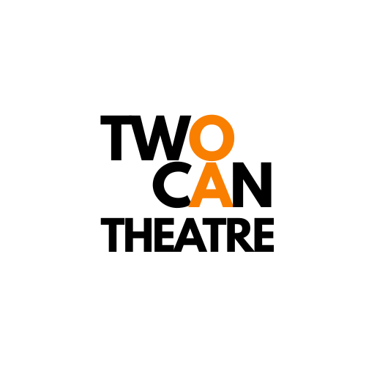
Equal Opportunities Monitoring Form

We are committed to equality in recruitment and aim to reflect the diverse communities we serve. To do this we need your help in filling out a short monitoring form. The information you provide will help support us ensure that our recruitment processes are fair to all and allow us to attract diverse and talented candidates.

Please highlight or underline how you would describe yourself for each aspect. You can select "prefer not to say" if you would rather not answer any question.
Please note that this information will not be used as part of the selection process.
Where did you hear about the role / opportunity you are applying for:
TwoCan website / Facebook / Instagram / Other (please specify)

Sex:
Female / Male / Prefer not to say / Prefer to self-describe (please state)

Gender:
Non-binary / Male/ Female / Other (please state) / prefer not to say

Is your gender identity the same as your sex recorded at birth?
Yes / No / Prefer not to say

Sexual Orientation:
Asexual / Bisexual / Gay / Heterosexual or Straight / Lesbian / Pansexual/ Queer / Prefer not to say / Other (please state)

Health and Disability
Do you consider yourself to be disabled or have a long term health condition that affects your day to day activities?
Yes / No / Prefer not to say
Do you identify as neurodivergent?
Yes / No / Prefer not to say

Religion or belief:
No belief / Buddhist / Christian / Hindu / Jewish / Muslim / Sikh /
Other religion or belief (please state) / Prefer not to say

Ethnicity:
Asian / Asian British
Bangladeshi / Chinese / Indian / Pakistani / Another Asian background background (please state) / Prefer not to say

Black / African / Caribbean / Black British:
African / Black British / Caribbean / Another Black, African or Caribbean background (please state) / Prefer not to say

Mixed or Multiple Ethnic Groups:
White and Asian / White and Black African / White and Black Caribbean/ Another mixed or multiple ethnic group (please state) Prefer not to say

Other ethnic group:
Arab / Other (please state) / Prefer not to say

White:
English / Welsh / Scottish / Northern Irish / Irish British/
Gypsy or Irish Traveller/ Other (please state) / prefer not to say

